1. Design the tables in database, attention their relationship and the constraint (primary key, foreign key)

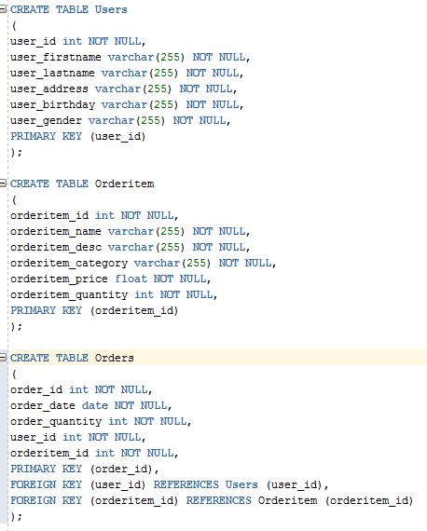

1. What are DQL, DML, DDL and DCL for Database? And what their commands? And give examples for each one based the above tables “User”, “Order” and “OrderItem”.

DQL(Data Query Language) – Select

DML(Data Manipulation Language) – Insert, Update, Delete

DDL(Data Definition Language) – Create, Drop, Alter

DCL(Data Control Language) – Grand, Rollback, Commit

